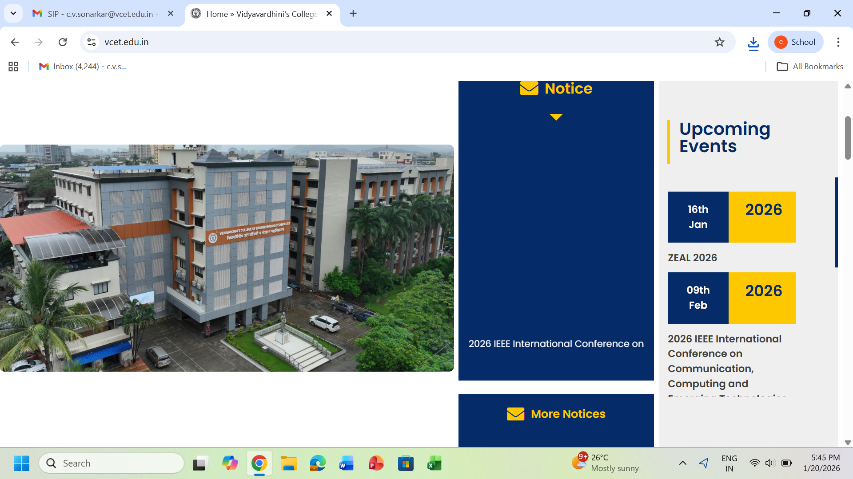

A REPORT ON STUDENT INDUCTION PROGRAMME FOR
FIRST YEAR STUDENTS FOR THE ACADEMIC YEAR 2025-26

CONTENTS
- Introduction
- Objectives of the Programme
- Programme Schedule (Timetable)
- Orientation Programme
- Overview of First Year Engineering Programme
- Induction Programme Activities
  - Introduction to Sports Committee
  - Introduction to Students’ Council
  - Institute Visit
  - Introduction to SAE Teams (Ethan, Solecthon, Airnova, Centurions, Emechto)
  - Introduction to Centers of Excellence
  - Introduction to NSS Committee
- Student Feedback (Summary)
- Outcomes of the Programme
- Photographs
- Acknowledgement

1. INTRODUCTION
Vidyavardhini’s College of Engineering and Technology organized a one-week Student Induction Programme for newly admitted First Year Engineering students, in line with AICTE guidelines. The programme was conducted from 8th September 2025 to 1st October 2025 and was further continued throughout the academic year. A total of approximately 700 students participated in the programme.
The induction programme was designed to ensure a smooth transition of students into the engineering education system by familiarizing them with the institutional culture, academic structure, faculty, and support systems.

2. OBJECTIVES OF THE PROGRAMME
- To make students feel comfortable in their new academic environment.
- To help students build confidence, openness, and peer bonding.
- To create a healthy daily routine and promote teamwork.
- To develop awareness about self, society, and nature.
- To bridge academic gaps through proficiency modules.
- To encourage excellence, ethical values, and holistic personality development.
The programme included motivational talks, team-building activities, expert lectures, campus orientation, and value-based sessions.

3. PROGRAMME SCHEDULE (TIMETABLE)
Date | Session | Time | Event
08/09/2025 | Session 1 | 10.00 am – 1.00 pm | Welcome by FE Coordinator
08/09/2025 | Session 2 | 2.00 pm – 5.00 pm | Introduction to Student Council & Sports Committee
09/09/2025 | Session 3 | 10.00 am – 1.00 pm | Institute Visit
09/09/2025 | Session 4 | 2.00 pm – 5.00 pm | Introduction to Ethan, Solecthon, Airnova & Centurions Teams
20/09/2025 | Session 5 | 10.00 am – 1.00 pm | Orientation Programme
10/09/ – 12/09/2025) | Session 6 | 10.00 am – 1.00 pm | Introduction to Centers of Excellence
01/10/2025 | Session 7 | 10.00 am – 1.00 pm | Introduction to NSS Committee

4. ORIENTATION PROGRAMME
An Orientation Programme for newly admitted First Year Engineering students was conducted on 20th September 2025 at Rajani Hall, Vidyavardhini’s College of Engineering and Technology, Vasai (W), District Palghar.
Dignitaries Present
- Dr. Rakesh Himte – Principal
- Dr. Vikas Gupta – Dean Academics
- Dr. Yogesh Pingle – Dean, Student Affairs
- Dr. Prafulla Patil – Placement In-Charge
- Dr. Sunayana Jadhav – FE Coordinator
- Ms. Chandrakishori Sonarkar – Student Induction Programme In-Charge
The programme began with the Garjana of Maharashtra Geet, followed by a warm welcome. The dignitaries addressed students on academic structure, NAAC accreditation, outcome-based education, placements, discipline, and opportunities for holistic development. The programme concluded with the National Anthem and a vote of thanks.

5. REPORT ON OVERVIEW OF FIRST YEAR ENGINEERING PROGRAMME
Event Name: Overview of First Year Engineering Programme
Date: 8th September 2025
Speaker: Dr. Sunayana Jadhav (FE Coordinator)
Attendees: First Year Engineering Students
The session introduced students to the curriculum structure, credit system, examination scheme, evaluation methods, institute vision, infrastructure, and code of conduct. Two batches were formed for smooth conduct, and over 600 students participated actively.
Objectives
- To orient students to the academic framework of First Year Engineering.
- To familiarize students with institutional values and expectations.
- To introduce faculty members and support systems.

Feedback Summary (Out of 5)

- Clarity of objectives: 4.25
- Understanding academic structure: 4.17
- Confidence in transition: 4.56
- Overall rating: 4.26

6. INDUCTION PROGRAMME ACTIVITIES
6.1 Introduction to Sports Committee
Date: 8th September 2025
The Sports Committee introduced its vision, activities, teams, and achievements through presentations, videos, interactive games, and senior-student interaction.
6.2 Introduction to Students’ Council
Date: 8th September 2025
The Students’ Council welcomed freshers and showcased cultural events like ZEAL through after-movies and interactive sessions with senior students.
6.3 Institute Visit
Date: 9th September 2025
Students visited the library, laboratories, workshops, computer centre, gymkhana, and Centers of Excellence to familiarize themselves with campus facilities.
6.4 Introduction to SAE Teams
Date: 9th September 2025
Teams including Ethan Racing Electric, Solecthon, Centurions, Airnova, and Emechto introduced their projects, achievements, and learning opportunities.
6.5 Introduction to Centers of Excellence
Date: 10th – 12th September 2025
Students were introduced to Siemens COE, Texas Instruments Lab, and e-Yantra Robotics Lab, highlighting industry-oriented learning and skill development.
6.6 Introduction to NSS Committee
Date: 1st October 2025
The NSS unit introduced students to community service, social responsibility, and leadership opportunities through interactive discussions and senior experiences.

7. STUDENT FEEDBACK (SUMMARY)
Overall feedback across all sessions reflected high satisfaction, clarity, engagement, and motivation, with average ratings above 4.0 out of 5.

8. OUTCOMES OF THE PROGRAMME
- Smooth academic and social transition of students.
- Enhanced awareness of academic structure and institutional culture.
- Improved confidence, motivation, and sense of belonging.
- Early interaction between students and faculty mentors.
- Encouragement towards extracurricular, technical, and social activities.

9. PHOTOGRAPHS
(Orientation Programme (Fig 1.1 - Fig.1.9), Committee Introductions, Institute Visit, and Induction Activities(Fig 2.1 – Fig 3.9)

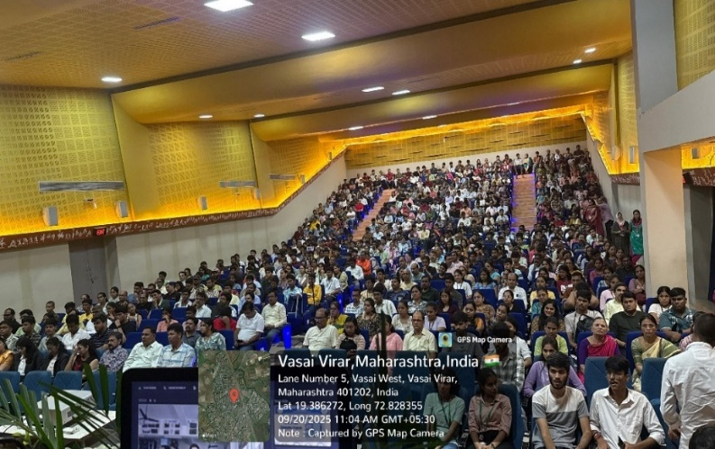  Fig 1.1 Students Parents engaged in Orientation Programme | 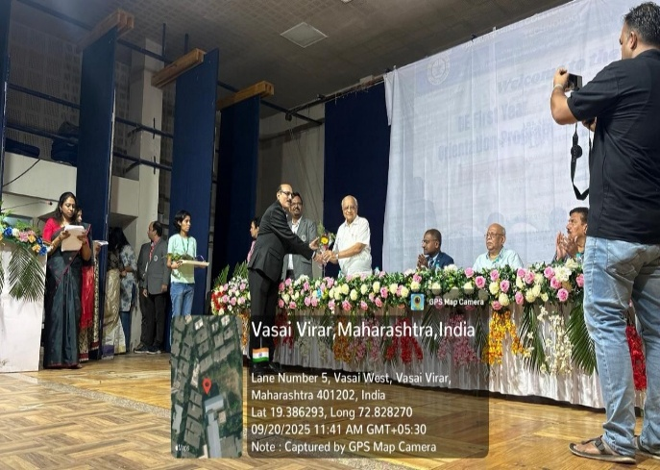  Fig 1.2 a) Felicitation Dignitaries on Dias by Principal Sir

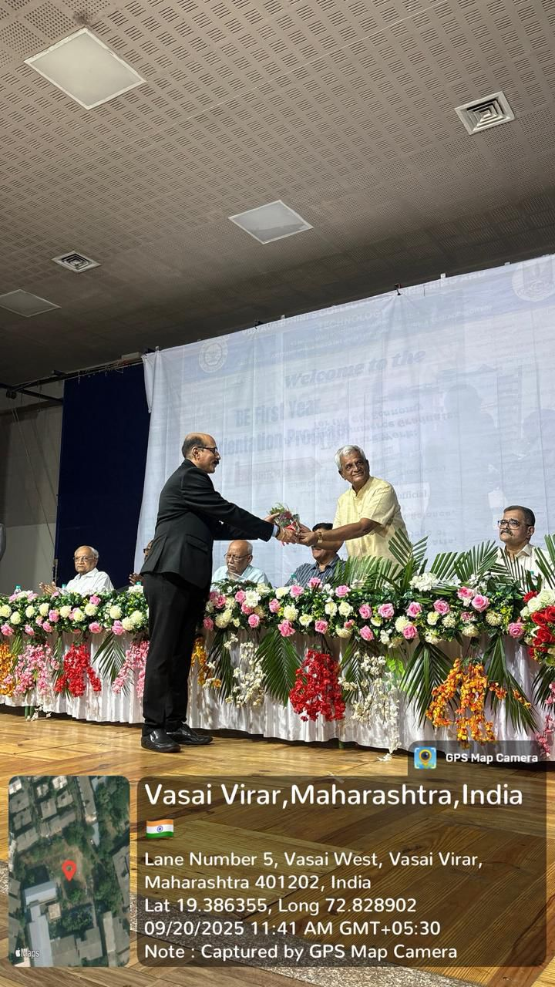  Fig 1.2 b) Felicitation Dignitaries on Dias by Principal Sir | 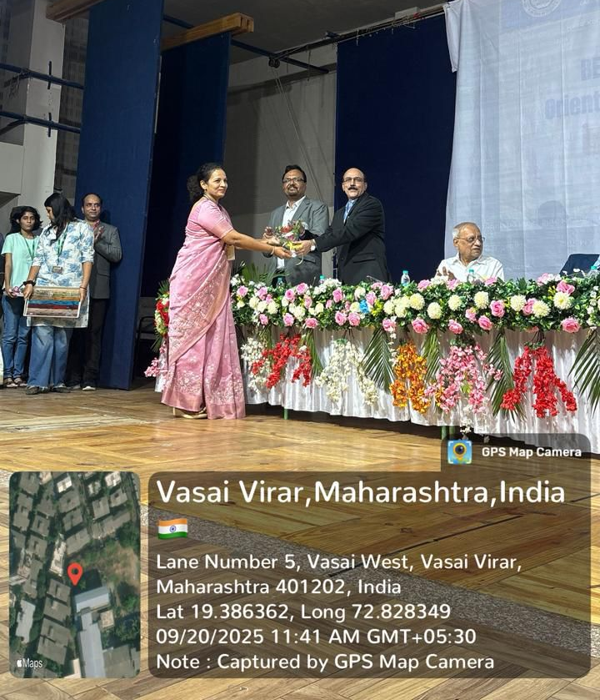  Fig 1.3 Felicitation of Principal Sir from Dr. Sunayna Jadhav (FE Co-ordinator)
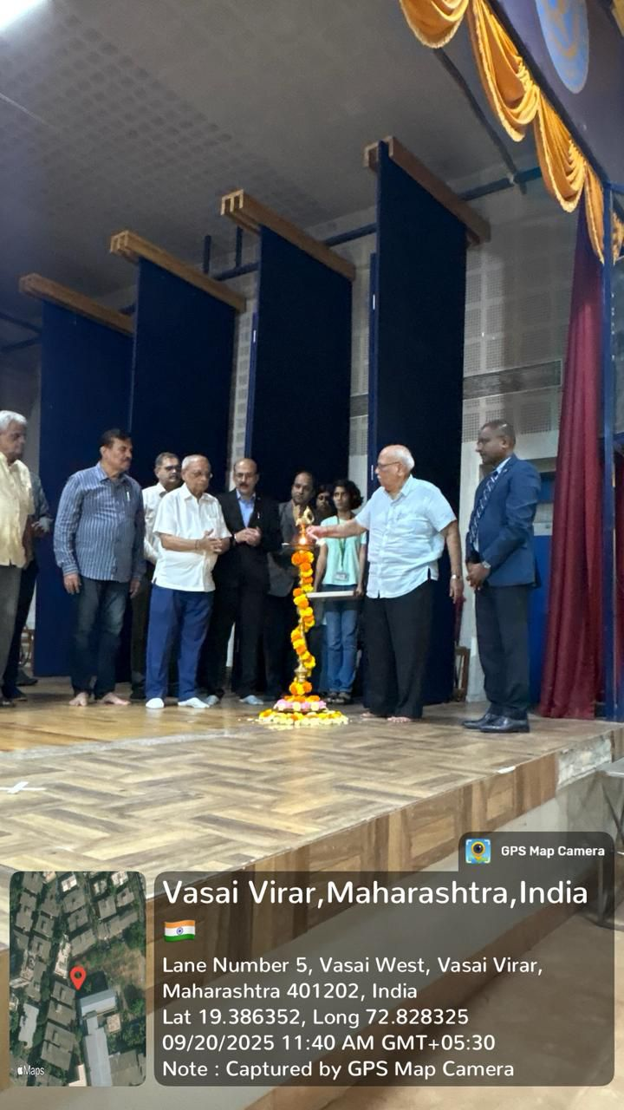  Fig 1.4 Lighting Lamp for Inauguration of Function | 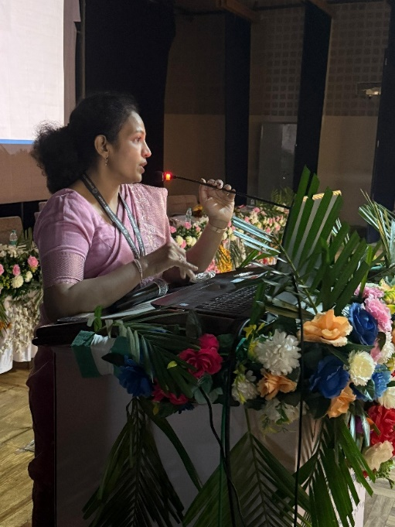  Fig 1.5 Dr. Sunayana Jadhav FE Coordinator explaining Rule & Regulation of FE Structure

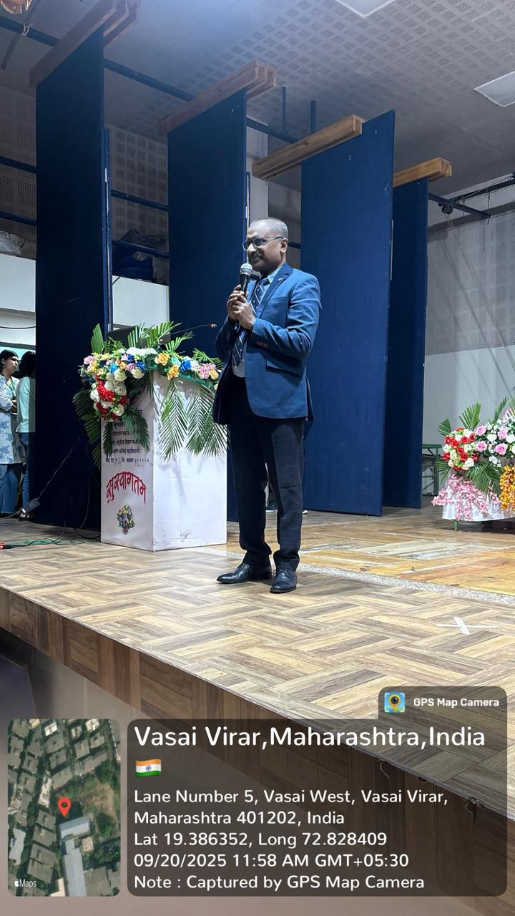  Fig 1.6 Motivation speech of Guest Speaker | 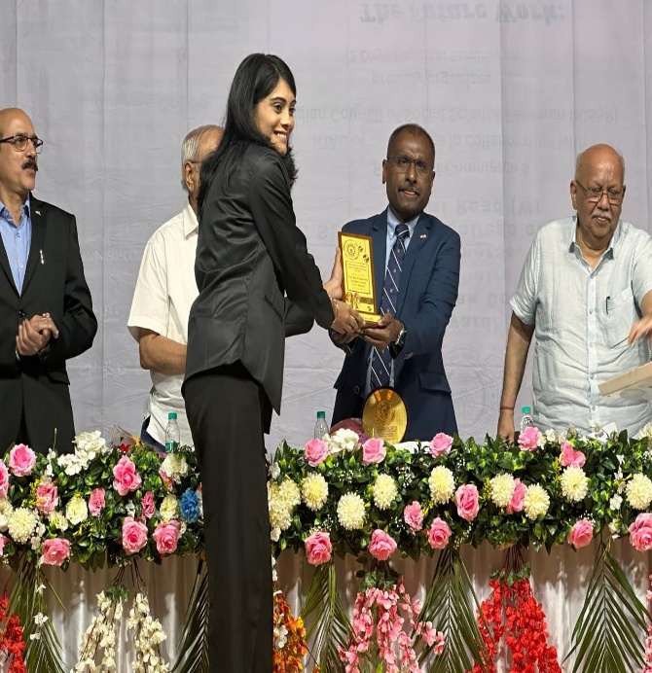  Fig 1.7 a) Award Given to outstanding Students
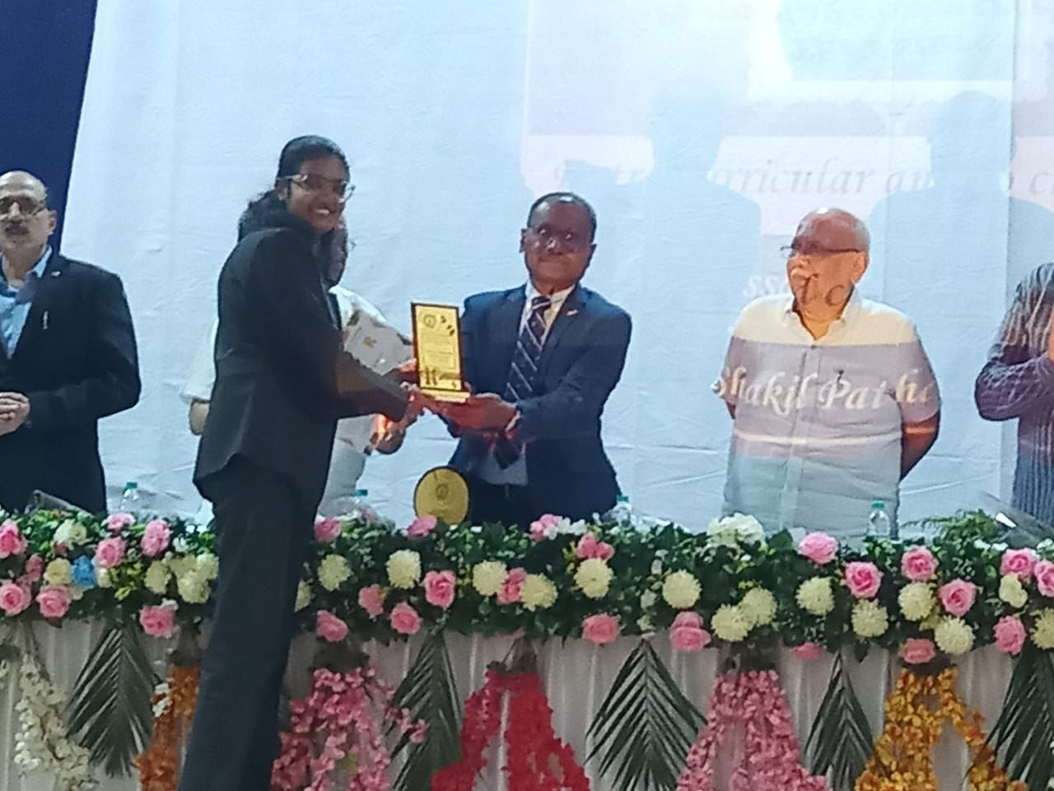  Fig 1.7 b) Award Given to outstanding Students | 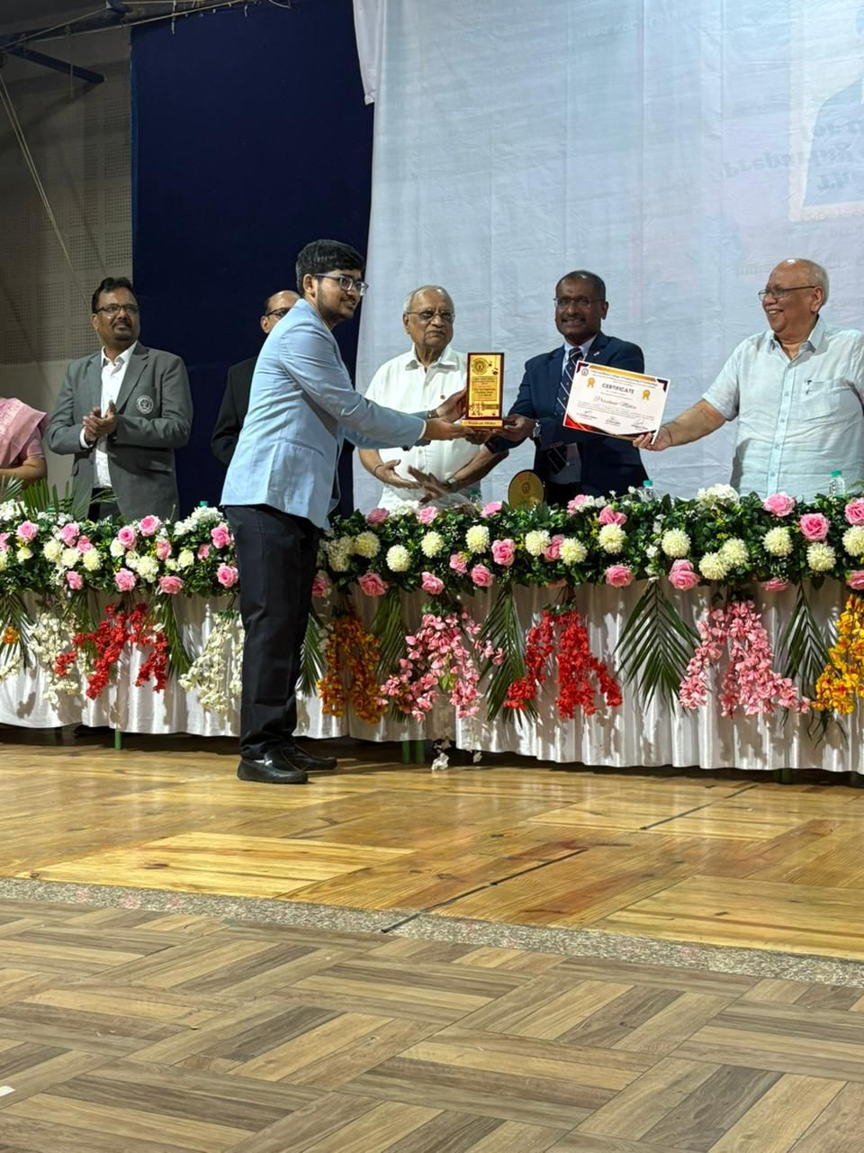  Fig 1.7 c) Award Given to outstanding Students

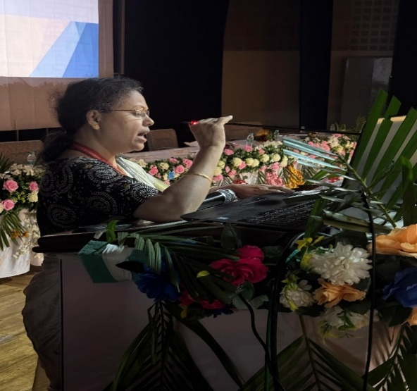  Fig 1.9 Ms. Chandrakishori Sonarkar, giving Vote of Thanks | 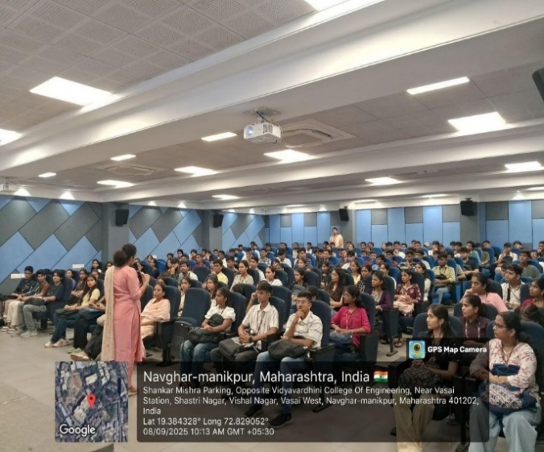  Fig 2.1 Dr. Sunayana Jadhav FE Coordinator address schedule of 1st week
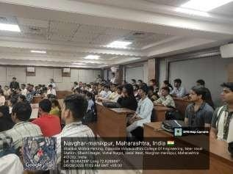  Fig. 2.2 Interaction with Student Council Committee | 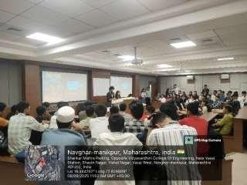  Fig 2.3 Interaction with Student Council Committee

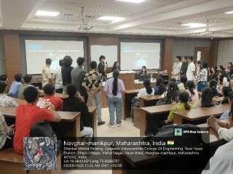  Fig 2.4 Interaction with Sports Committee | 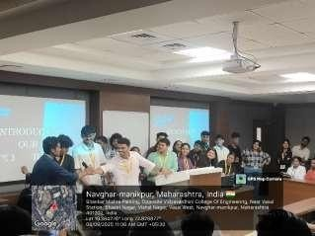  Fig 2.5 Interaction with Sports Committee
P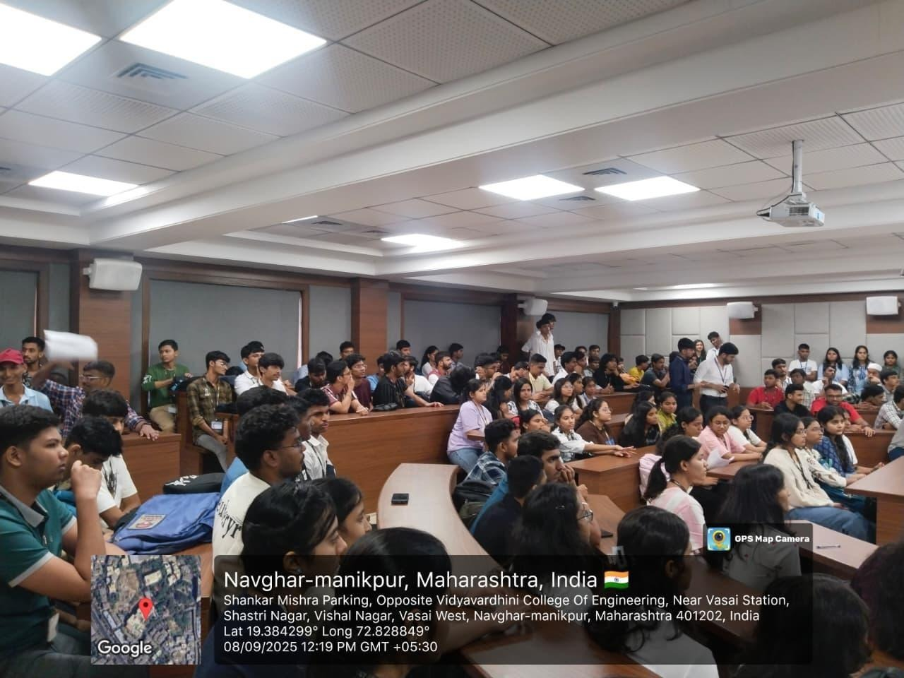  Fig 2.6 Physics Lab Visit | 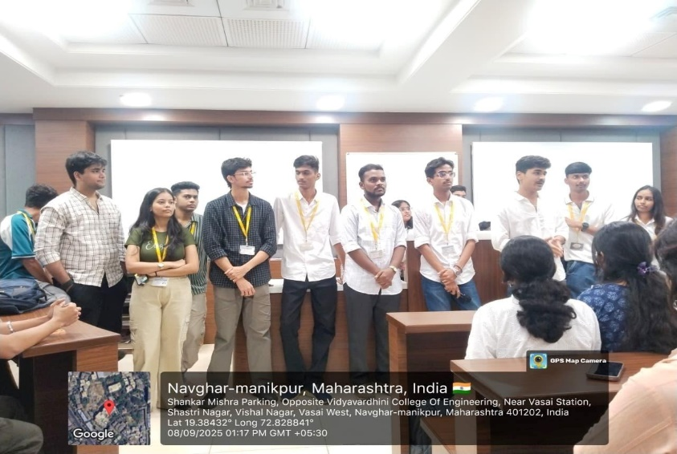  Fig 2.7 Introduction to Centers of Excellence
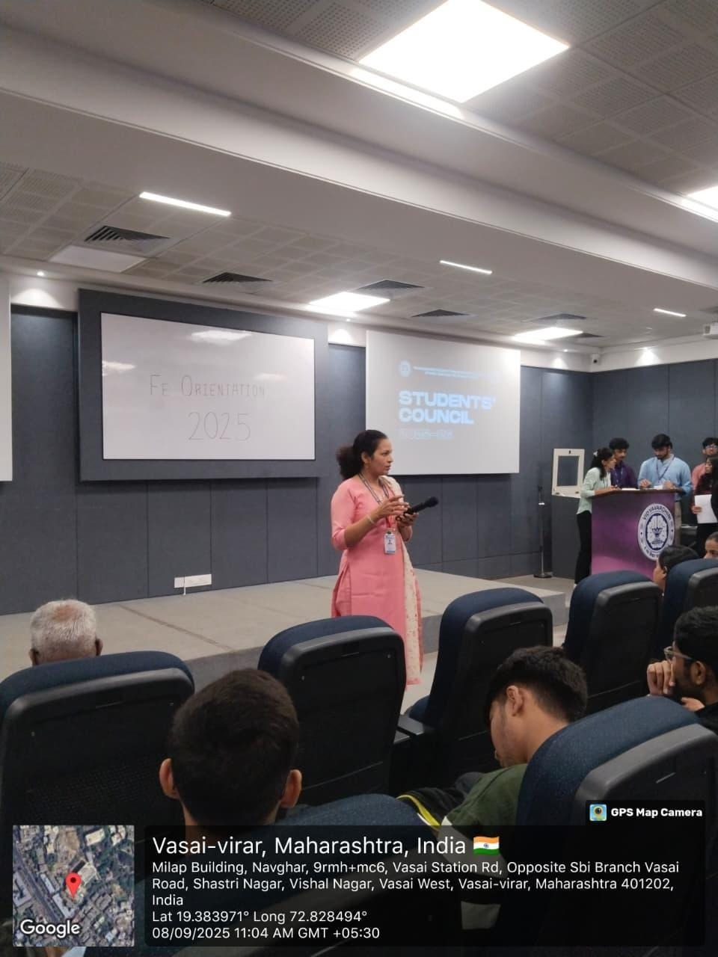  Fig 2.8 Introduction to Centers of Excellence | 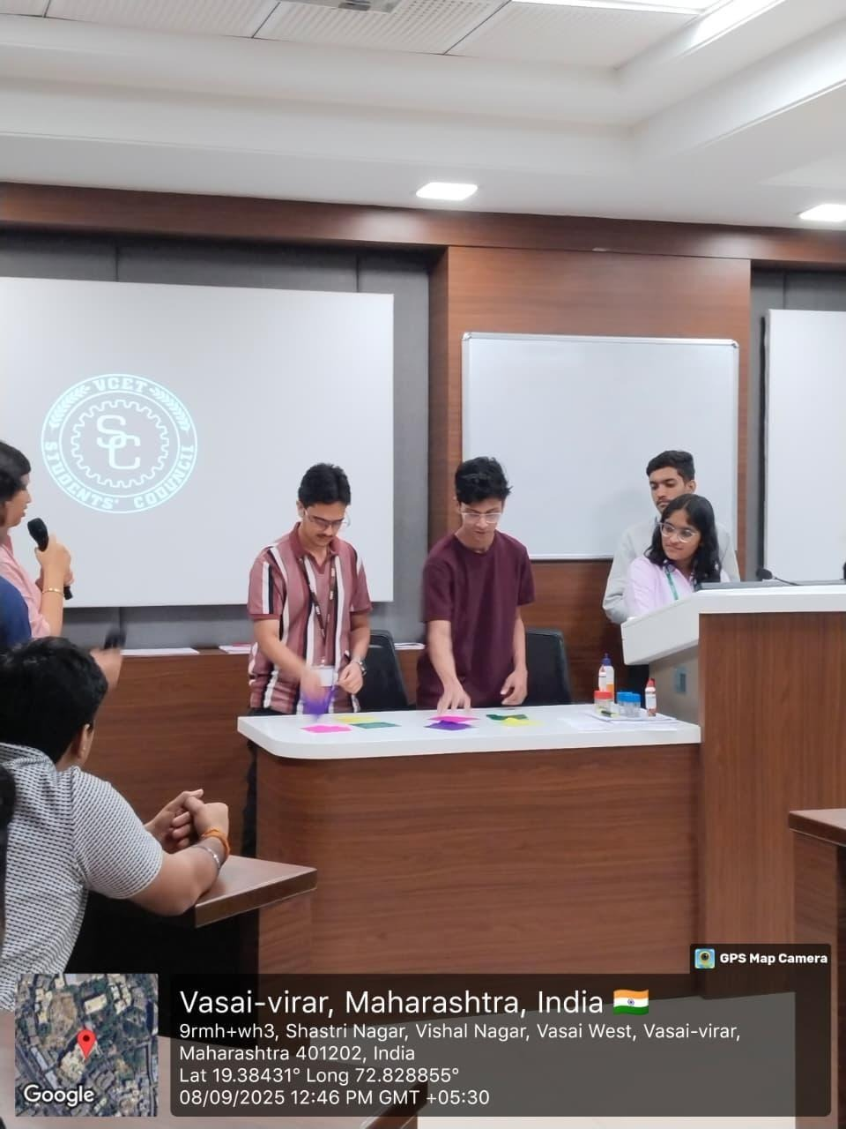  Fig 2.9 Sports Activity
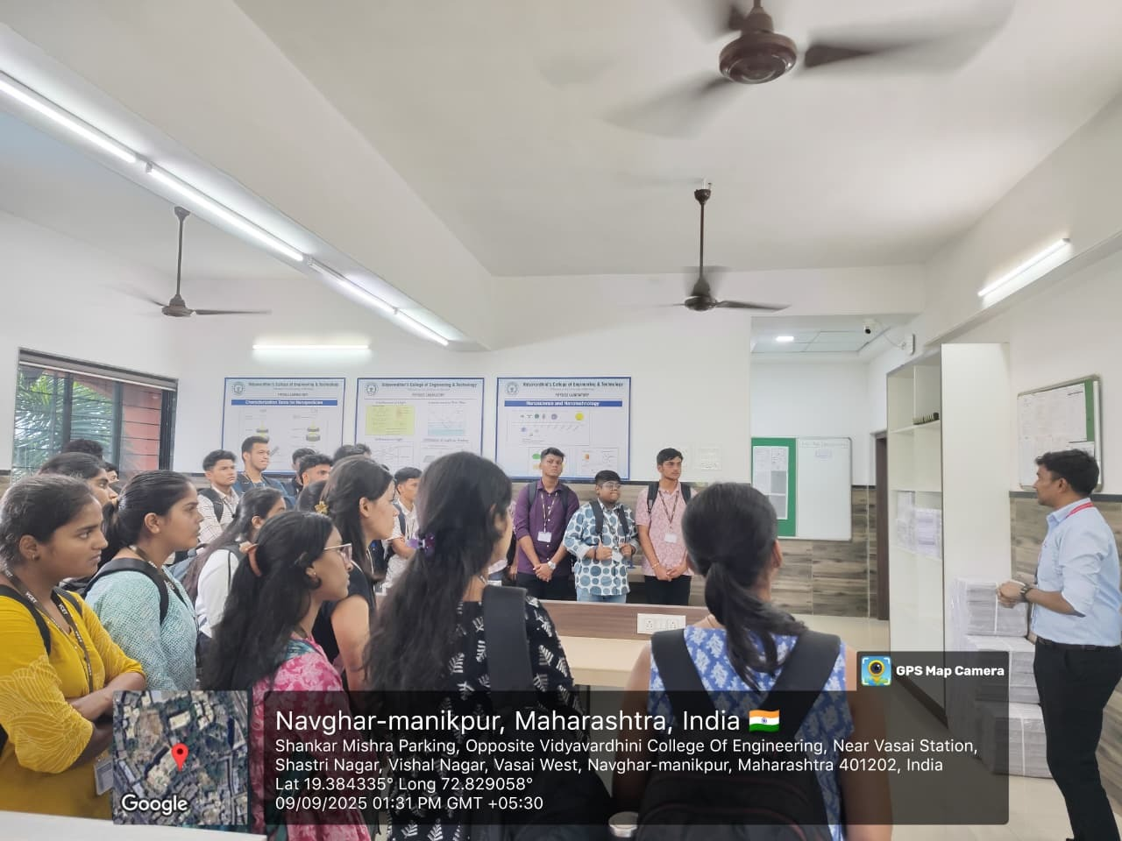 | 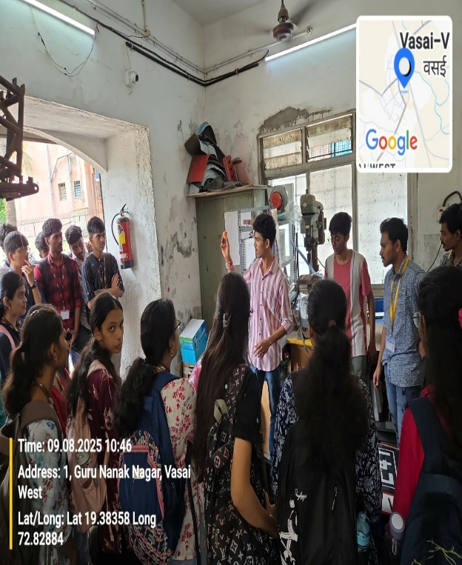

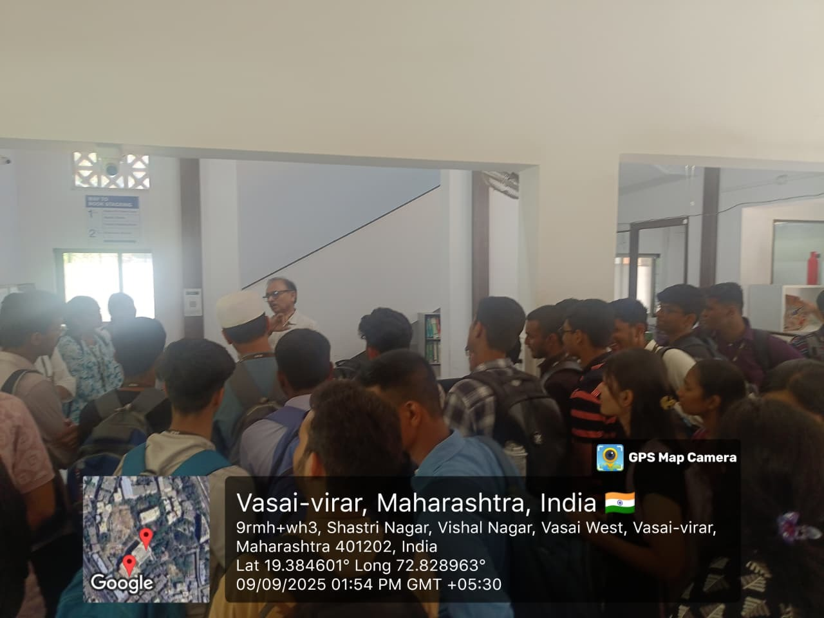Fig 3.1 Library Visit | 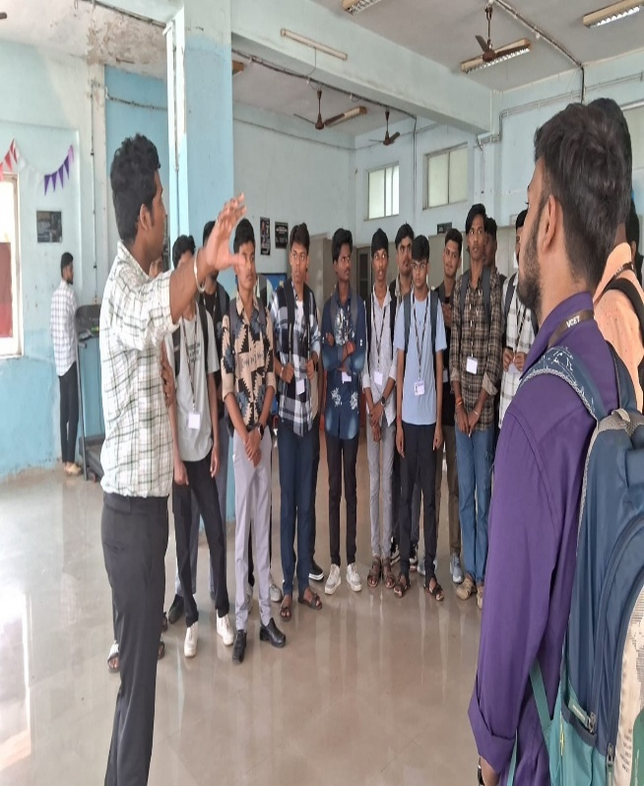  Fig 3.2 Gymkhana Visit
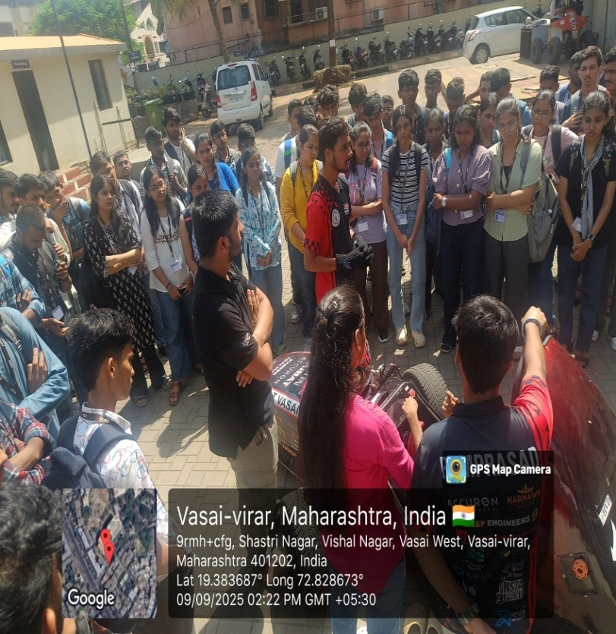  Fig 3.3 VISIT to Team VCET Ethan Racing | 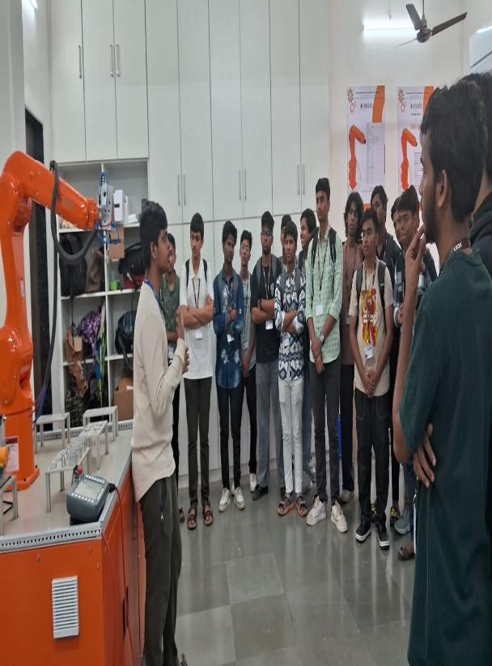  Fig 3.4 VISIT to Team VCET Solecthon

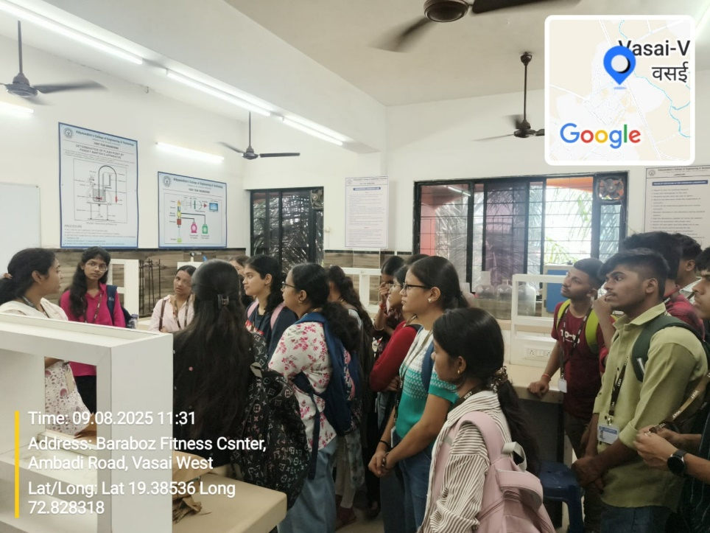  Fig 3.5 Chemistry Laboratory Visit | 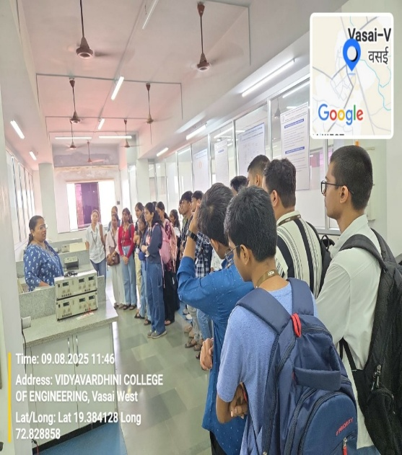  Fig 3.6 BEEE Laboratory Visit
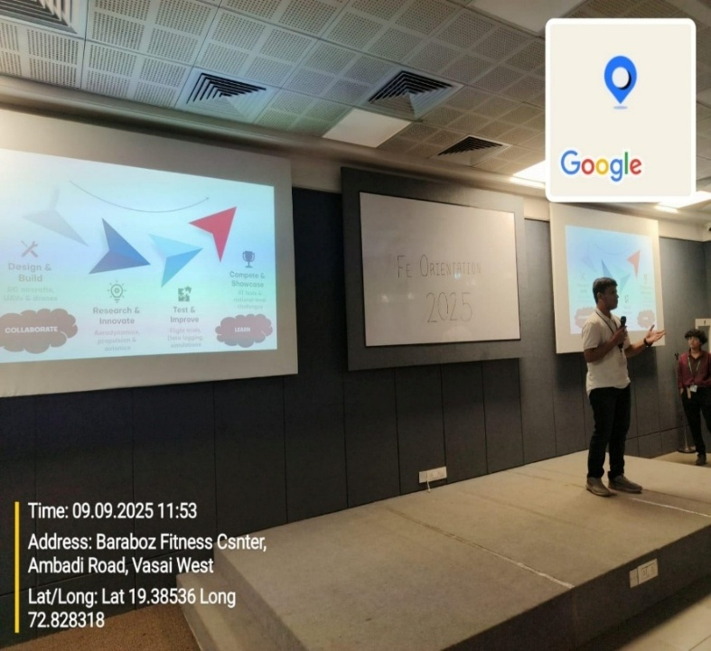 | 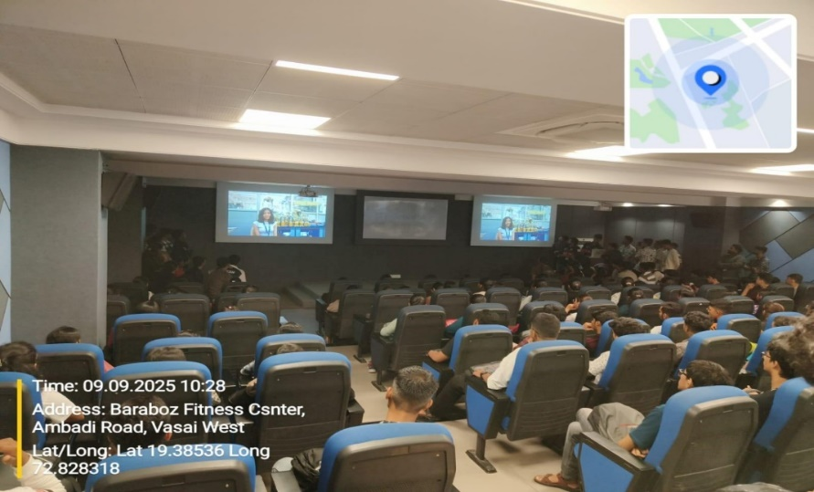

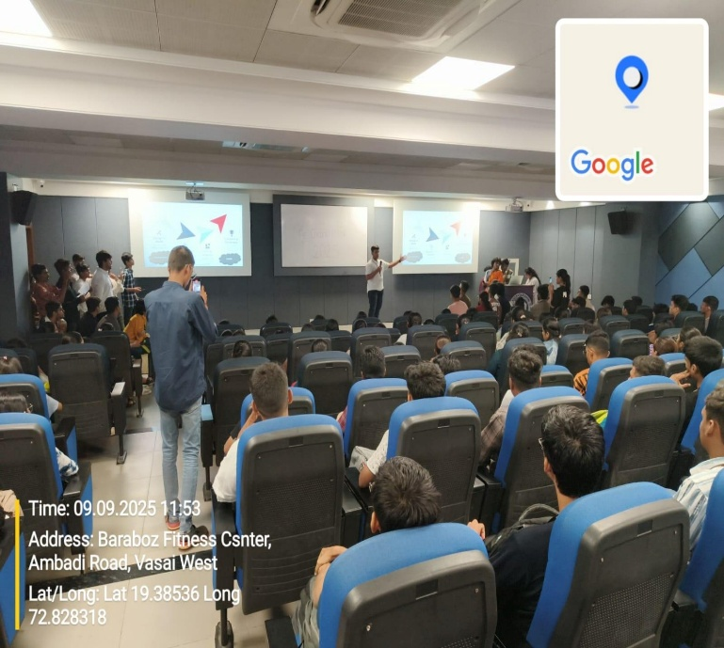 | 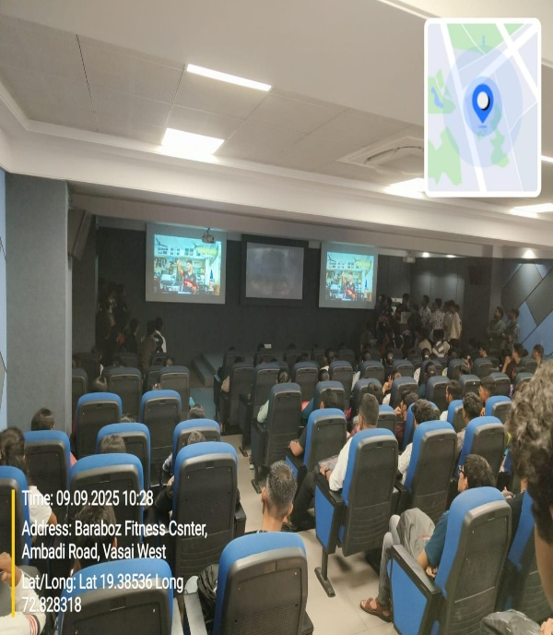
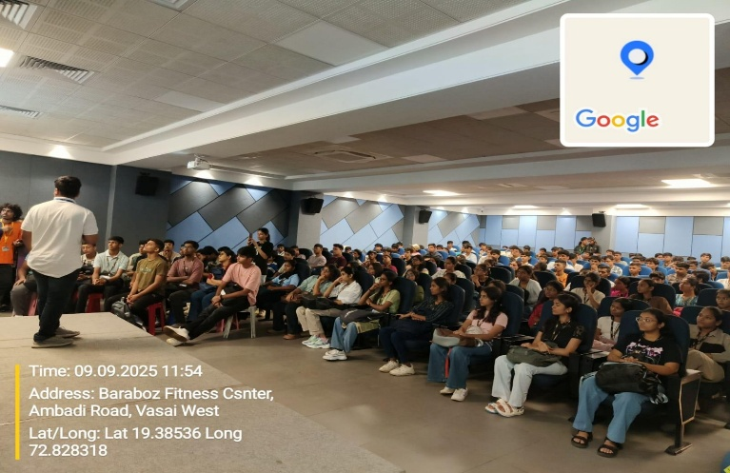 | 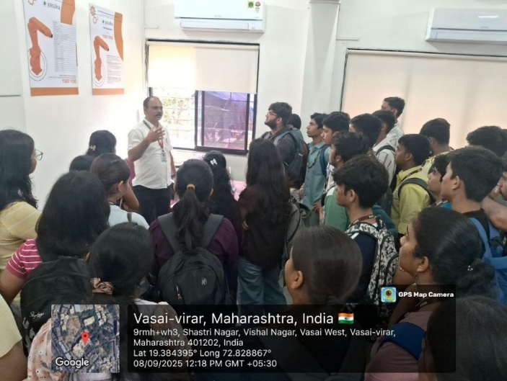  Fig 3.7 Language Lab Visit

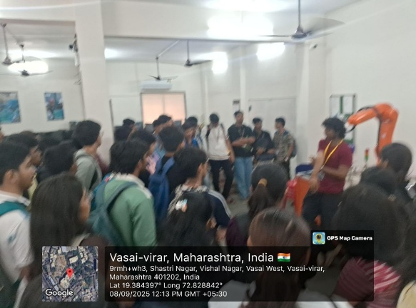  Fig 3.8 Basic Workshop Laboratory Visit | 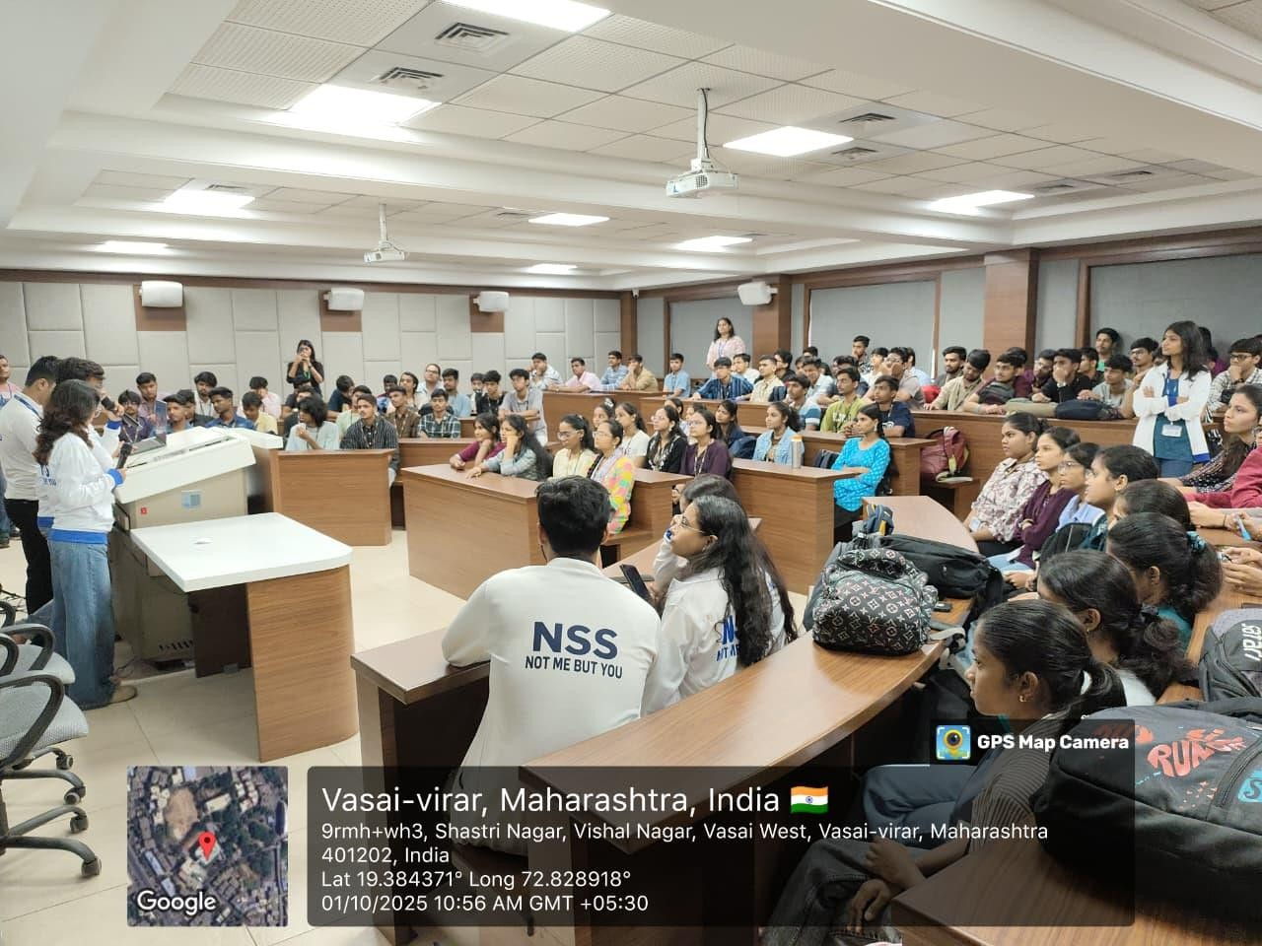  Fig 3.9 NSS Activity
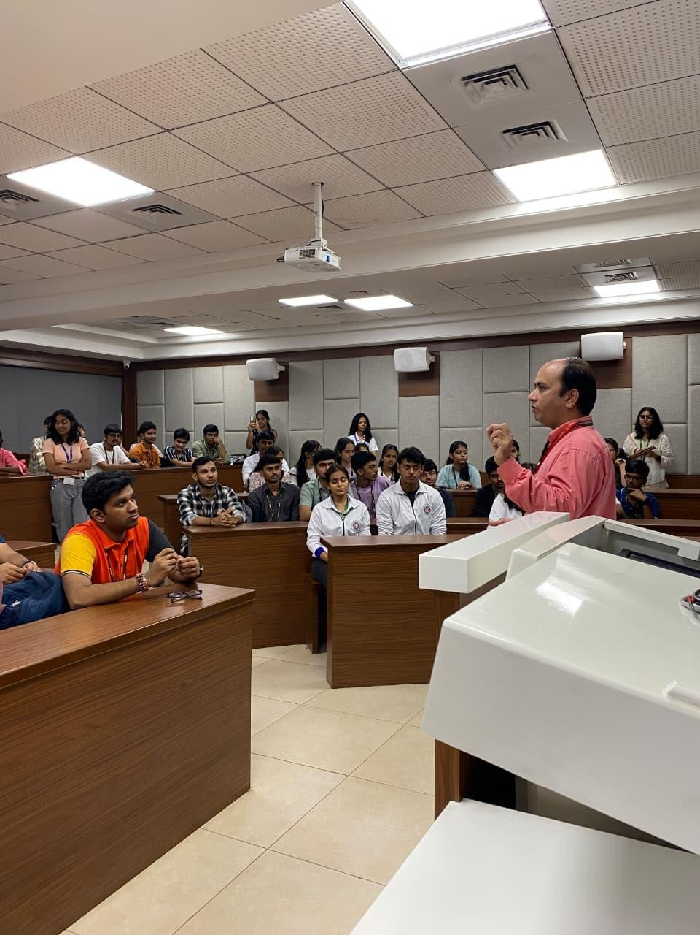  Fig 3.9 a) NSS Activity | 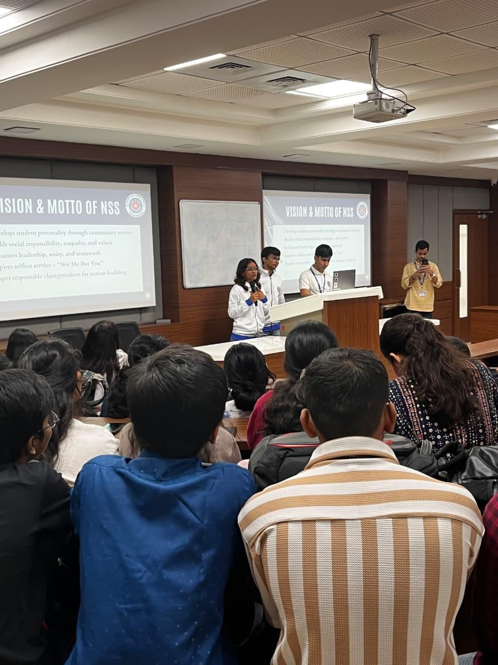  Fig 3.9 b)NSS Activity

10. ACKNOWLEDGEMENT
The successful execution of the Student Induction Programme was made possible through the guidance and support of the Principal, Deans, FE Coordinator, faculty members, non-teaching staff, student volunteers, and committee members. The institute extends sincere thanks to all contributors for their valuable efforts in welcoming and mentoring the First Year Engineering students.

