Name of Alumni | SHUBHAM CHOUDHARI | 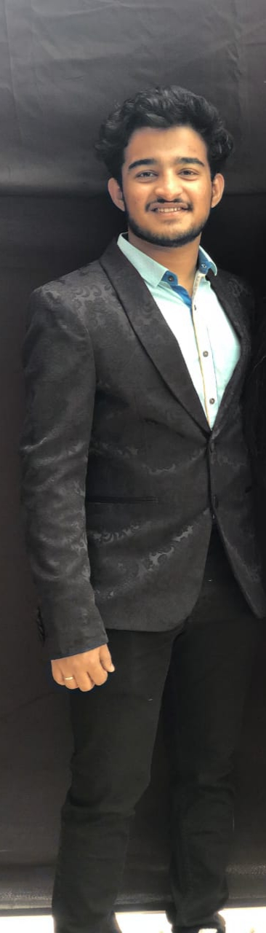
Year of Passing | 2021
Job profile | Technical university of Denmark, Masters in Transport and Logistics
Testimonial | Unlike a lot of alumni, we weren’t able to spend entire four years into the college, due to the Corona pandemic. But as it is said “Less is more” that is what has been my experience with VCET. The three years that I spent as a student have transformed me into a person today, who wishes to continue his studies further. Not only in terms of studies but overall personality and perspective of mine has been developed, credits, to this college and its environment. Syllabus is supposed to be same overall through out the University, but it is the college and its initiatives that brings out something different of the students, which this college definitely does. The amount of extracurricular and cocurricular activities that this college provides, motivates students to break out of their comfort zones and explore things beyond the books. Along with such facilities present, the students require support and this support is been provided by the faculty. In my 4 years of Engineering, I have been part of committees like CESA and the Students’ Council and never once was I forced to be a cent percent study oriented, in fact all my achievements in both the committees were highly praised and celebrated by the faculties. The amount of time spent in classrooms and the labs is one to remember and for sure would be a big part of my journey further. There are a lot of things that I learned here that would help me with my life in Denmark.
DEPARTMENT OF CIVIL ENGINEERING

