Name of Teaching Staff | Puja C. Kadam | 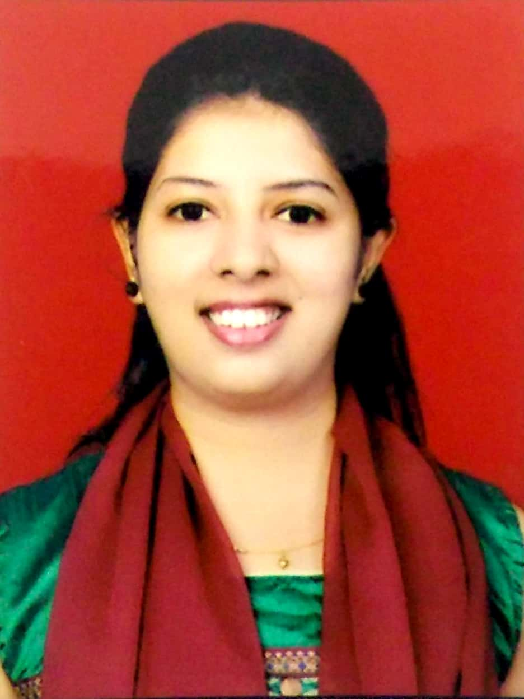
Designation | Assistant Professor
Department | Civil Engineering
Date of Joining the Institution | 27/07/2016
Qualifications with Class / Grade | M.E. Civil and Environmental , I class with Distinction
Specialisation | Water and Sewage Treatment, Waste Management, Environmental Engineering
Email Address | puja.kadam@vcet.edu.in
Total Experience in years | 07
Papers Published | 11
Books Published / IPRs / Patents | -
Professional Memberships | Indian Society for Technical Education(ISTE), Indian Water Works Association( IWWA)
Consultancy Activities | -
Awards | -
Grants fetched | -
Website Link | www.pujatlp.wordpress.com
E-Resources | NPTEL courses, Virtual Labs, YouTube videos
You Tube Link | https://youtube.com/channel/UC-n1CL-upNlLn59-V2EOocQ

