Name of Teaching Staff | Mr. Jignesh M. Mistry | 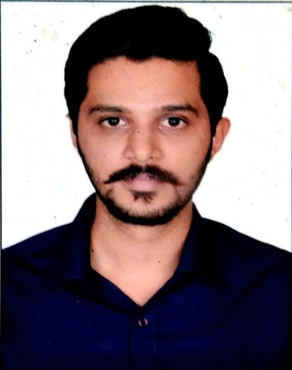
Designation | Assistant Professor
Department | Civil Engineering
Date of Joining the Institution | 3rd February 2017.
Qualifications with Class / Grade | M.E., First Class with Distinction
Specialisation | Construction Engineering & Technology
Email Address | jignesh.mistry@vcet.edu.in
Total Experience in years | 5
Papers Published | 4
Books Published / IPRs / Patents | None
Professional Memberships | Indian Green Building Council (IGBC) Accredited Professional
Consultancy Activities | -
Awards | Ranked 2nd in Half Marathon Race held at Avahan 2021
Grants fetched | None
Website Link | -
E-Resources | -
You Tube Link | -

