Name of Teaching Staff | Viren Bhikaji Chandanshive | 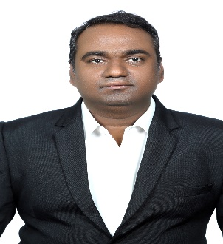
Designation | Assistant Professor
Department | Civil Engineering
Date of Joining the Institution | 26 Jul 2016
Qualifications with Class / Grade | - B.E. Civil from Govt. College of Engineering, Karad with 66.88 %.  - M.E. Civil (Construction Management) from Sardar Patel College of Engineering, Mumbai with 8.85 pointers.  - PhD. Civil (Pursuing) from Sardar Patel College of Engineering, Mumbai.
Specialisation | Construction Management
Email Address | viren.chandanshive@vcet.edu.in
Total Experience in years | 8
Papers Published | 16
Books Published / IPRs / Patents
Professional Memberships
Consultancy Activities
Awards
Grants fetched
Website Link | https://virenchandanshive.wordpress.com/
E-Resources
You Tube Link

