Name of Teaching Staff | Jaydeep Bandopant Chougale | 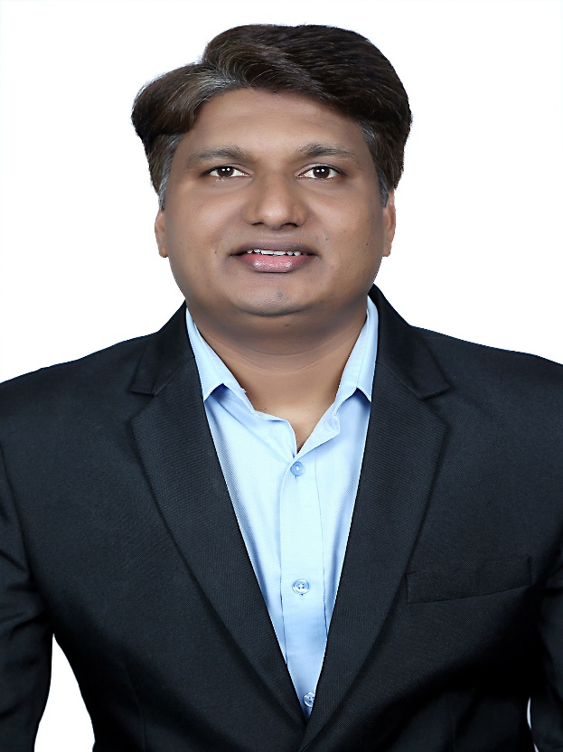
Designation | Assistant Professor
Department | Civil Engineering
Date of Joining the Institution | 28/07/2016
Qualifications with Class / Grade | B.E (Civil), M.E (Structural Engineering), Ph.D. Pursuing
Specialisation | Structure, Concrete
Email Address | jaydeep.chougale@vcet.edu.in
Total Experience in years | 13
Papers Published | 09
Books Published / IPRs / Patents | -
Professional Memberships | ISTE
Consultancy Activities | -
Awards | -
Grants fetched | -
Website Link | -
E-Resources | -
You Tube Link | -

