Name of Teaching Staff | Aishwarya Anil | 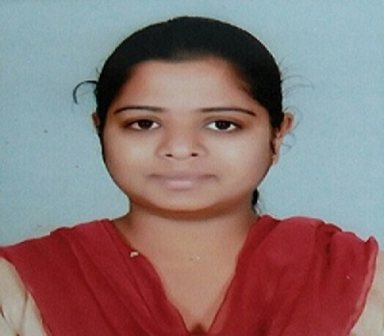
Designation | Assistant Professor
Department | Civil Engineering
Date of Joining the Institution | 27/01/2021
Qualifications with Class / Grade | M.tech- 8.28  B.E- 7.84  12th-60.40%  10th-75.44
Specialisation | Structural Engineering
Email Address | Aishwarya.anil@vcet.edu.in
Total Experience in years | 2.5 years
Papers Published | 1
Books Published / IPRs / Patents | -
Professional Memberships | 1
Consultancy Activities | -
Awards | -
Grants fetched | -
Website Link | -
E-Resources | -
You Tube Link | -

