Program: BE Computer Engineering
Curriculum Scheme: Revised 2016
Examination: Third Year Semester VII
Course Code: CSDLO7031 and Course Name: Advanced System Security and Digital Forensics
Time: 1 hour Max. Marks: 50
Note to the students:- All the Questions are compulsory and carry equal marks .
Q1. | When a cyber attacker knows the type of person he is attacking and tries to break the passwords using the victim's date of birth, pets name, etc. What kind of attack is this?
Option A: | Dictionary Attacks
Option B: | Inferring Passwords Likely for a User
Option C: | Brute Force Attacks
Option D: | Exhaustive Attacks
Q2. | The given diagram showcases what type of security model/management?  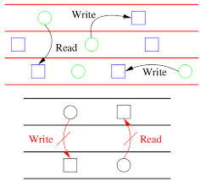
Option A: | Biba
Option B: | Federated Identity
Option C: | Single Sign-on
Option D: | Bell Lapadula
Q3. | The given diagram showcases what type of security model/management?  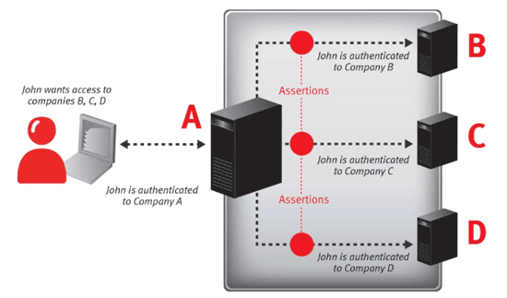
Option A: | Biba
Option B: | Federated Identity
Option C: | Single Sign-on
Option D: | Bell Lapadula
Q4. | By mitigating it is meant that,
Option A: | The harm should be made less severe
Option B: | Causing of the harm should be made difficult
Option C: | The harm should be stopped from happening
Option D: | Virus Attack
Q5. | A method to confine users to one side of a boundary is called:
Option A: | Compound
Option B: | Firewall
Option C: | Fence
Option D: | Back Door
Q6. | When one or more extra bits are given to identify the access rights to that word, it is called as
Option A: | Based and Bound Registers
Option B: | Tagged Architecture
Option C: | Fence
Option D: | Back Door
Q7. | Worms are:
Option A: | Non-Malicious Codes
Option B: | Malicious Codes
Option C: | Targeted Malicious Code
Option D: | Selectively malicious
Q8. | Covert Channels are:
Option A: | Non-Malicious Codes
Option B: | Malicious Codes
Option C: | Targeted Malicious Code
Option D: | Selectively malicious
Q9. | This attack can be deployed by infusing a malicious code in a website’s comment section. What is “this” attack referred to here?
Option A: | SQL injection
Option B: | HTML Injection
Option C: | Cross Site Scripting (XSS)
Option D: | Cross Site Request Forgery (XSRF)
Q10. | _______ Protocol under SSL indicated that the upcoming data is protected.
Option A: | Record Protocol
Option B: | Change Cipher Spec
Option C: | Alert
Option D: | Handshake
Q11. | Privileges of trusted user is used in which attack?
Option A: | Cross Site Scripting
Option B: | Account Harvesting
Option C: | Cross Site Request Forgery
Option D: | Phishing
Q12. | The session token could be compromised in different ways; the most common are:  - Predictable session token  - Session Sniffing  - Man-in-the-middle attack
Option A: | i and ii
Option B: | ii and iii
Option C: | i and iii
Option D: | i, ii and iii
Q13. | IEEE 802.11i is called as
Option A: | Wired Equivalent Security
Option B: | Robust Security Protocol
Option C: | Robust Security Network
Option D: | Wired Equivalent Protocol
Q14. | Error detection is performed at which level of IEEE 802
Option A: | Physical
Option B: | Medium Access Control
Option C: | Logical Link Control
Option D: | Transport
Q15. | IEEE 802 committee was formed for developing which standards
Option A: | LAN
Option B: | WLAN
Option C: | WEP
Option D: | WPA
Q16. | IEEE 802.11i has come out with what protocol
Option A: | HTTP
Option B: | WEP
Option C: | WPA
Option D: | WPA2
Q17. | Which is generally considered as crime against Society
Option A: | Cyberterrorism
Option B: | Cyberdefamation
Option C: | Logic Bomb
Option D: | Pornographic offenses
Q18. | Which is generally considered as crime against organisation
Option A: | Phishing
Option B: | Cyberdefamation
Option C: | Logic Bomb
Option D: | Pornographic offenses
Q19. | The Intellectual property rights of Kolhapuri Chappal can be protected under__________.
Option A: | Patents
Option B: | Designs
Option C: | Copyrights
Option D: | Geographical Indications
Q20. | ____________ generally evolves through court decisions
Option A: | Criminal and Civil Law
Option B: | Contract Law
Option C: | Tort Law
Option D: | Personal Law
Q21. | The three A’s in digital Forensics are  - Acquire  - Authenticate  - Apply  - Analyse  - Appraise
Option A: | i, ii, and iii
Option B: | i, ii, and iv
Option C: | i, iii and v
Option D: | ii, iii and iv
Q22. | Forensic duplicate is stored is stored in what format?
Option A: | Original
Option B: | Raw
Option C: | JPEG
Option D: | HTML
Q23. | _______ adds significant amount of functionality in duplication like block based hashes and a progress indicator.
Option A: | dc
Option B: | dd
Option C: | dcfldd
Option D: | dfl
Q24. | A ________________ is a file that contains every bit of information from the source, but may be stored in an altered or changed form.
Option A: | Forensic Duplicate
Option B: | Qualified Forensic Duplicate
Option C: | Restored Image
Option D: | Mirror Image
Q25. | A system tool that enumerates all listening ports and all current connections to those ports
Option A: | Fport
Option B: | Pslist
Option C: | Netstat
Option D: | ipconfig

